**ONLY IN SILENCE CAN YOU HEAR THE VOICE OF THE UNIVERSE**

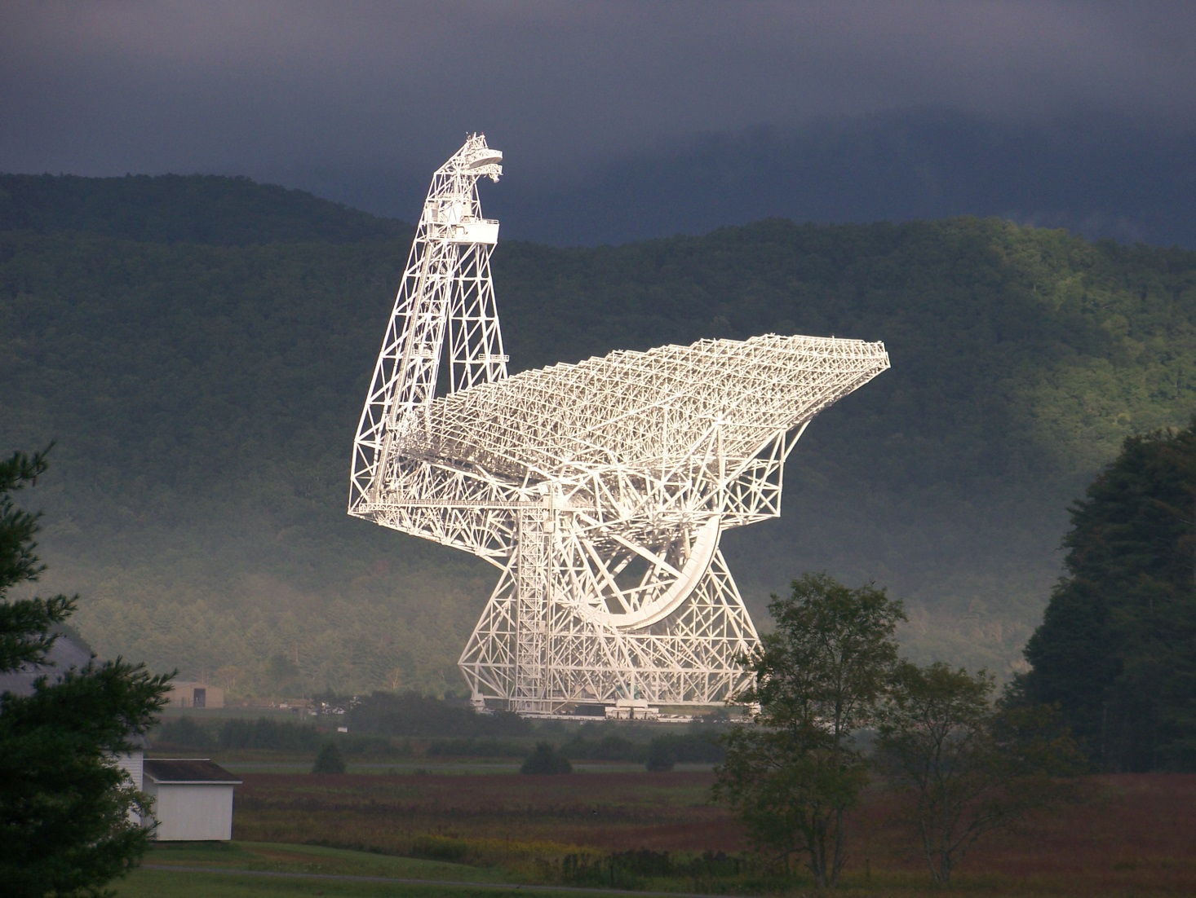

Many of you may have heard of the National Radio Astronomy Observatory (NRAO) located in Green Bank, WV. This facility is home to an extremely high-tech operation dedicated to basic astronomy research in radio wavelengths and science education and outreach to all ages. Due to the extremely sensitive nature of the equipment here, the area surrounding Green Bank has been protected against spurious, interfering electrical transmissions (Radio Frequency Interference, or RFI) since 1956 by the State of West Virginia, through passage of the West Virginia Radio Astronomy Zoning Act (WVRAZ), and the Federal Government since 1958, through passage of the National Radio Quiet Zone (NRQZ). Each zone protects the operations here in a different way, and these will be explained in detail further on.

On August 31 our NRQZ administrator, Paulette Woody, was contacted by an amateur radio operator regarding the upcoming ARRL VHF contest that is going to be held in September. The caller explained that he was planning on operating his gear on a mountain top near the Green Bank Observatory, on Barton Knob in WV. He wanted to inquire if his operation would be a problem for the Observatory; he didn’t want to interfere with our observations.

This started a discussion where the typical questions relating to coordination were asked, and led to the explanation of the difference between the federal and state regulations under the NRQZ rules and the WVRAZ code. After discussing his proposed, temporary installation, it was clear that we would put out an Observer Alert which would advise astronomers and telescope operations of the potential interference due to the contest.

In sending out the Observer Alert, our Head of Scientific Operations questioned if we could deconflict transmissions in the 33 cm band. This band is being used for the NANOGrav project (<http://nanograv.org/>), a multi-year international project to detect gravitational waves in space, and a project in which the GBT is one of the primary instruments for the observations.

This internal discussion prompted Paulette to contact ARRL to see if they would publish web links and contact information that would point potential contesters to the NRQZ coordination page of NRAO. ARRL reached out and here we are, writing an article asking for voluntary coordination from amateur radio operators that are operating within a 10 mile radius of either the GBT in Green Bank, WV or the Sugar Grove Research Station in Sugar Grove, WV.

**A LITTLE ABOUT THE NRAO AND THE GBT**

The NRAO in Green Bank, WV, houses 8 radio telescopes of various sizes, but the crowned jewel is the Green Bank Telescope (GBT). The GBT is the world premiere astronomical telescope operating from centimeter to millimeter wavelengths, and is the largest fully-steerable radio telescope in the world. Its enormous 100 x 110 meter diameter collecting area, its unblocked aperture, and its excellent surface accuracy provide unprecedented sensitivity across the telescope's full 0.1 - 116 GHz (3.0m - 2.6mm) operating range.

The single focal plane is ideal for rapid, wide-field imaging systems – cameras.  Because the GBT has access to 85% of the celestial sphere, it serves as the wide-field imaging complement to the Atacama Large Millimeter Array (ALMA) in Chile, South America and the Jansky Very Large Array (VLA) in Socorro, New Mexico. Its operation is highly efficient, and it is used for astronomy about 6500 hours every year, with 2000-3000 hours per year available to high frequency science.

Part of the scientific strength of the GBT is its flexibility and ease of use, allowing for rapid response to new scientific ideas.  It is scheduled dynamically to match project needs to the available weather.  The GBT is also readily reconfigured with new and experimental hardware, adopting the best technology for any scientific pursuit. Facilities of the Green Bank Observatory are also used for other scientific research, for many programs in education and public outreach, and for training students and teachers. The Observatory has an active engineering research and development program ranging in areas from digital, mechanical, structural, computational, and software engineering.  The laboratories, utilities and support facilities make it an attractive location for a variety of research experiments, and it serves as the field station for several university-based research teams.  The Observatory is also a major resource for STEM education and public outreach and is used for an extensive array of programs in education and public outreach, and for the training of science and engineering students and teachers. These activities center on the Green Bank Science Center, with its auditorium, classrooms, research facilities and large exhibit hall, which is visited by 50,000 people every year.

**THE WVRAZ AND NRQZ**

The WVRAZ, West Virginia State Code Chapter 37A “Radio Astronomy Zoning Act”, was passed into law in 1956. Simply put the law states that it shall be unlawful to operate or cause to be operated any electrical equipment within a radius of ten miles of the reception equipment of any radio astronomy facility, with instantaneous peak field strength measurement results at various distances within this 10 mile radius being listed. Below is a map of the 10 mile radius under the protections of the WVRAZ.

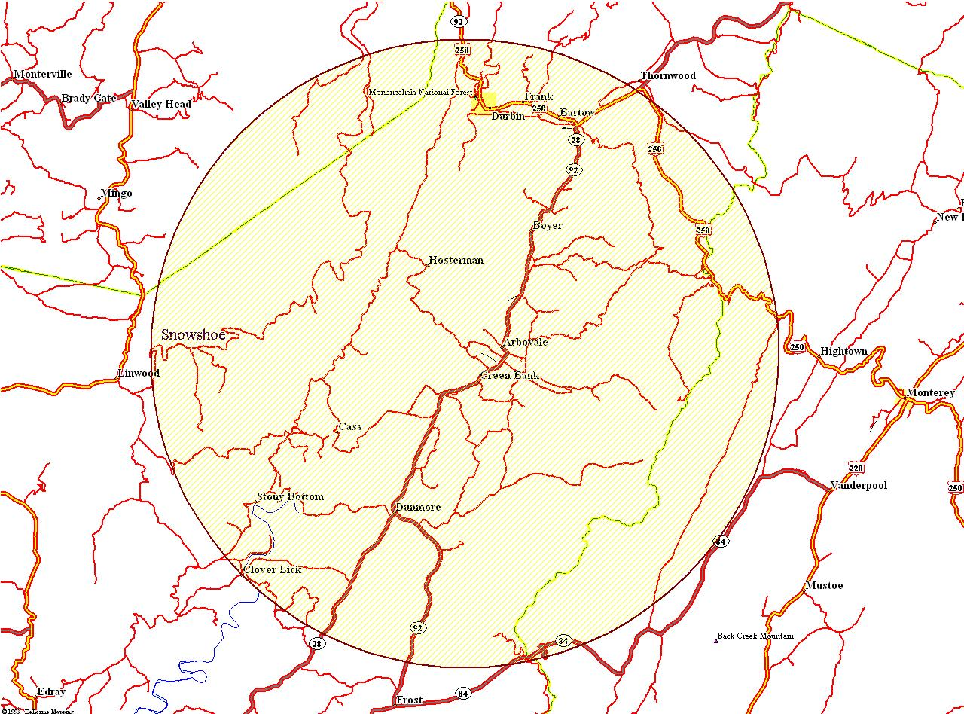

The 10 mile radius of the WVRAZ in Pocahontas County, WV

The NRQZ was established by the Federal Communications Commission (FCC) in [Docket No. 11745](http://www.gb.nrao.edu/nrqz/FCC_Docket_11745_NRQZ.pdf) (November 19, 1958) and by the Interdepartment Radio Advisory Committee (IRAC) in Document 3867/2 (March 26, 1958) to minimize possible harmful interference to the National Radio Astronomy Observatory (NRAO) in Green Bank, WV and the radio receiving facilities for the United States Navy in Sugar Grove, WV. The NRQZ is bounded by NAD-83 meridians of longitude at 78d 29m 59.0s W and 80d 29m 59.2s W and latitudes of 37d 30m 0.4s N and 39d 15m 0.4s N, and encloses a land area of approximately 13,000 square miles near the state border between Virginia and West Virginia. The following black and white map is from the NTIA Manual of Regulations and Procedures for Federal Radio Frequency Management (Redbook).

[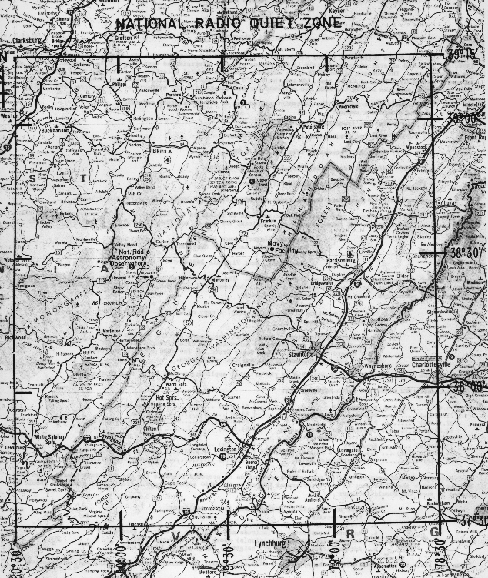](http://www.gb.nrao.edu/nrqz/NTIA_map_bw.gif)

The National Radio Quiet Zone (NRQZ)

Simply put, NRQZ coordination is required for all new or modified, permanent, fixed, licensed transmitters inside the NRQZ, as specified for federal transmitters by [NTIA manual](http://www.ntia.doc.gov/osmhome/redbook/redbook.html) section 8.3.9 and for non-federal transmitters by the FCC in [47 CFR](http://www.gpo.gov/fdsys/pkg/CFR-2010-title47-vol1/content-detail.html) section [1.924](http://www.ecfr.gov/cgi-bin/text-idx?SID=f10ae54b1985c25568641f9555a0ea8e&mc=true&node=pt47.1.1&rgn=div5).

The applicable radio services include but are not limited to: Public Mobile, Wireless Communications, Maritime, Aviation, Private Land Mobile, Personal Radio, Fixed Microwave, International Fixed Public, Satellite Communications, Radio Broadcast, Experimental Radio, Auxiliary and Special Broadcast, Cable Television Relay, Amateur Radio, Personal Communications Service, General Wireless Communications Service. Geographic Area Licensed Services are NOT exempt from NRQZ coordination. Applicants for some radio services are required to file their applications through independent frequency coordinators (e.g. APCO, AASHTO, PCIA, and IMSA). The coordinators assume the responsibility of notifying the Interference Office that an FCC application has been filed and hold the application until the Interference Office responds with its evaluation.

These are the only quiet zones like them on the planet, and because of them the GBT has the best protection of any US observatory from many forms of man-made radio frequency interference. Additionally, the Observatory's location in a lightly-populated valley in the Monongahela National Forest, surrounded by extensive ranges of mountains in all directions, provides further protection from interfering signals. Due to this location, the Green Bank Observatory also becomes the home to many projects looking for radio quiet skies, some of which operate at very low frequencies, such as the NANOGrav project and projects searching for the remnants of the Big Bang.

**THE ARRL, AND THE VHF CONTEST**

It is an amazingly heartwarming thing for us when a member of the public thinks of our work and the potential effect his/her transmissions may have on that work, whether or not they are within the strict boundaries of the WVRAZ or NRQZ. We followed-up our conversation with the applicant specifically asking that they avoid, if at all possible, any directional transmissions that would cross path with the GBT (located at 38-25-59.2N, 79-50-23.4W), and to check out our GBT Schedule which would indicate what specific times the NANOGrav project would be observing.

We will also send out an email to all amateur applicants of which we have record, asking them to pass the word about the NANOGrav project and limiting operations in the 33 cm band to times other that what is shown in our schedule. The current schedule, updated every 24 hours, can be viewed at <https://dss.gb.nrao.edu/schedule/public> .

**MORE THAN RADIO ASTRONOMY**

The Green Bank Observatory has a rare combination of assets: 1) a laboratory where frontier research is an ongoing activity; 2) a professional staff of scientists and engineers who are also involved in education; 3) facilities such as the Green Bank Science Center, radio telescopes, housing and food services, all available for education and outreach. The Observatory staff use these assets to develop and present programs that would not be possible at other institutions. It is a showcase for NSF-funded basic research. The Green Bank Observatory hosts numerous programs for teachers. Residential teacher institutes provide a research experience for K-12 teachers and pre-service teachers through projects on the 40-Foot Radio Telescope under supervision of the Green Bank staff. Begun in 1987 and supported initially by the NSF and NASA, this program has trained over 1000 teachers in the fundamentals of scientific research. Each year, a Chautauqua Short Course Program for undergraduate college faculty is held to update their content knowledge. In the several dozen years of the program, over 650 undergraduate faculty have participated. Over the past 13 years, the NSF-sponsored Research Experience for Teachers has matched 27 teachers from grades 7-12 with Green Bank astronomers to perform astronomical research over an 8-week summer period. All these activities involve site scientists and engineers as lecturers, advisors, and mentors. The Pulsar Search Collaboratory (PSC) is a unique program in partnership with West Virginia University that enables middle and high school students to participate in active pulsar research using data from the Green Bank Telescope. In a summer residential program, high school teachers and their students work with astronomers to learn how to analyze data produced by the telescope, and then form PSC teams back at their schools. Funded by the NSF, the Collaboratory has so far engaged 103 teachers and 709 students from 18 states in pulsar research. Student teams have thus far discovered 6 new pulsars and one transient object, increasing the interest in science and technology at their schools, and gaining national recognition. Further information can be found at these links: <http://www.nrao.edu/pr/2007/pulsarcollab/> and <http://www.nrao.edu/pr/2011/studentpulsar/>

A new NSF-funded program is giving middle-school-aged youth the chance to take remote control of the NRAO 20-meter diameter telescope, bringing the excitement of hands-on research to young people via 4-H, the nation’s largest youth development organization. Skynet Junior Scholars will provide some 1,400 4-H youth with access to robotically-operated, research-grade telescopes. They will use the telescopes to survey galaxies, track asteroids, monitor variable stars, and learn first-hand how scientific research is done. In addition to the NRAO 20-meter radio telescope, the network includes optical telescopes in Wisconsin, North Carolina, Chile and Australia (<http://www.nrao.edu/pr/2012/skynet/>).

The 40-Foot telescope is a working radio telescope outfitted specifically for use by students and teachers. It is the centerpiece of a hands-on research experience offered by the Green Bank staff. Each year a total of 2500-3000 scouts, students and teachers visit Green Bank in groups ranging in size from 10-40 for visits that often last several days. The groups are housed in the site bunkhouse and have meals in the cafeteria. They receive training, full access and use of the 40-Foot telescope, in-depth tours of the electronics labs, and interactions with the Observatory staff (<http://www.gb.nrao.edu/epo/fieldtrip.shtml> ).



The 40 Foot Radio Telescope with some student users.

**WHY YOU SHOULD VISIT**

The Green Bank Observatory has a fantastic educational Science Center that caters to children and adults of all ages. The Science Center is a multi-purpose building that draws 50,000 visitors each year, a remarkable number for so remote a location. Visitors experience the many interactive displays in a 4,000 square-foot exhibit hall, partake in presentations about radio astronomy from the Science Center staff, and enjoy a guided bus tour around the site. The Science Center is also used for monthly star parties, an annual 4-day gathering of amateur astronomers called Star Quest, the annual meeting of the Society of Amateur Radio Astronomers, community days, and other events. It serves as the focus for school field trips throughout the year. As an amateur or professional radio operator, you will certainly enjoy viewing the many interactive exhibits and discussions that occur daily (<http://www.nrao.edu/index.php/learn/gbsc>).



The NRAO Green Bank Science Center.